|  |
| --- |
| **[ 2ceit604 User experience design]** |
|  |

Practical: 4

**AIM: Learn Techniques of UI & UX to design Mockup/Prototype from Wireframe by adjusting Color, fonts, etc.**

* **Explain types of Wireframe design**
* **Explore & Write down new three techniques to create UX design**
* **Create High-fidelity wireframe of web pages created in practical-2.**



**Department of Computer Engineering/Information Technology**

**Q.1 Explain types of Wireframe design**

* There are three main types of wireframes.
* [Low-fidelity wireframes](https://www.visme.co/wireframe-software/)
* Mid-fidelity wireframes
* High-fidelity wireframes
  1. Low-fidelity wireframes
* The first and simplest type is the low-fidelity wireframe. These are created either by hand, or with a digital tool.
* Low-fidelity wireframes are meant to be created fast and loose, without any design elements at all. Think of it as the skeleton of a website or app. The choice to create these by hand or with a tool depends solely on the work style of each person.
* There are printable templates for sketching wireframes on paper, and there are plenty of low-fidelity templates and kits to create these online.
* The main idea in a low-fidelity wireframe is to be as minimal as possible. Use only grayscale, one generic font, and no images or design effects like shadows.
  1. Mid-fidelity wireframes
* A mid-fidelity wireframe is more elaborate than a low-fidelity wireframe and closer to the intended final UI design. The wireframe might show images, more detailed visualizations of what’s intended for the layout, and interactions between pages are clearer and more elaborate than in a low-fidelity wireframe.
* A mid-fidelity wireframe can either be a continuation and improvement of a low-fidelity wireframe or the first step. For example, if this is the second or third wireframe for the same brand, it might not be necessary to start at low-fidelity.
  1. High-fidelity wireframes
* The third type of wireframe is high-fidelity. This is the wireframe type closest to how the UI design will look in the finished project. The UI components, images, icons, colors, fonts, buttons and backgrounds are in place and ready to be turned into a working prototype.
* A high-fidelity wireframe is not always the best place to start with a UX/UI project. If you don’t have a good base with a low-fidelity wireframe that has been tested for usability and with a few iterations, you’ll have to do these things in a high-fidelity wireframe. This takes up too much time.

Q.2 **Explore & Write down new three techniques to create UX design.**

### 2.1 Wireframe

A [wireframe](https://www.experienceux.co.uk/faqs/what-is-wireframing/) is a skeletal framework of your product, app, or website design. It is a blueprint of the design without any content, images, and interactive elements. The purpose of a wireframe is to lay out the functionality and content of the page, showing where a design element will be present on the screen.

### 2.2 Prototype

A [prototype](https://www.uxpin.com/studio/blog/what-is-a-prototype-a-guide-to-functional-ux/) is an outline of the proposed final product that is used for testing before launch. Low-level prototypes showcase a bare-bones sketch of how a design will look. High-level prototypes, on the other hand, add more details to the sketch, but aren’t full-design mockups.

### 2.3 Mockup

A [mockup](https://www.uxpin.com/studio/blog/what-is-a-mockup-the-final-layer-of-ui-design/) is a realistic representation of how the design will finally look in the end. Bear in mind that a mockup looks exactly like the final product. This means that it is formed after all the revisions to the design have been made.

**Q.3 Create High-fidelity wireframe of web pages created in practical-2.**

**3.1 Login:**

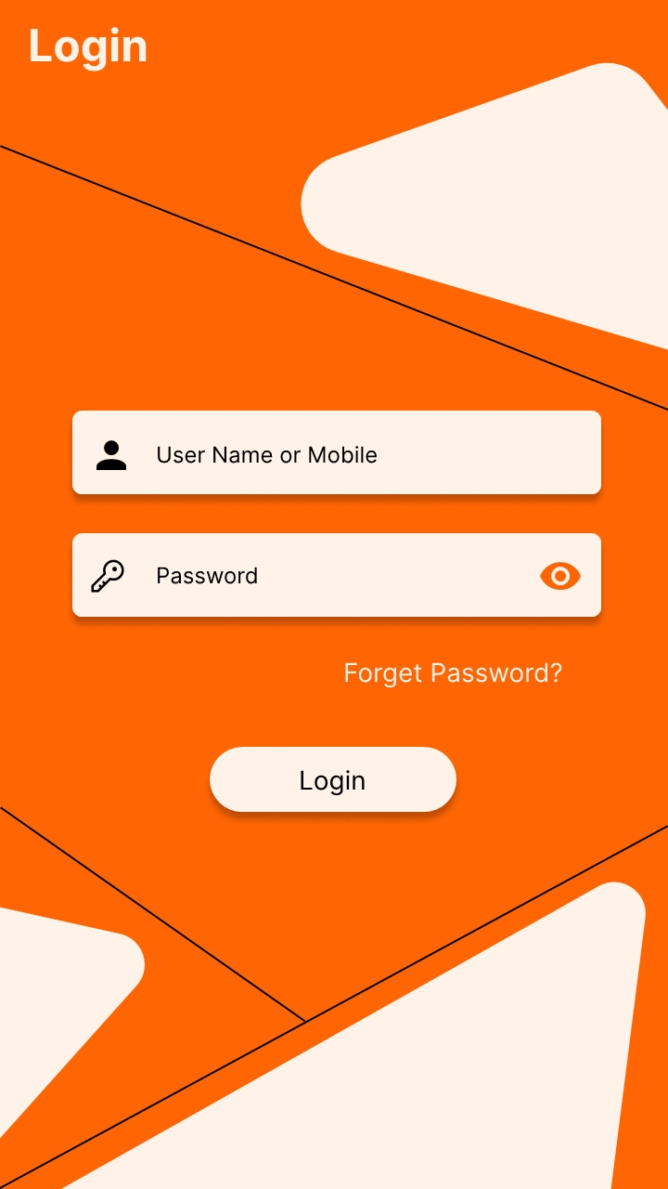

**3.2 Register:**

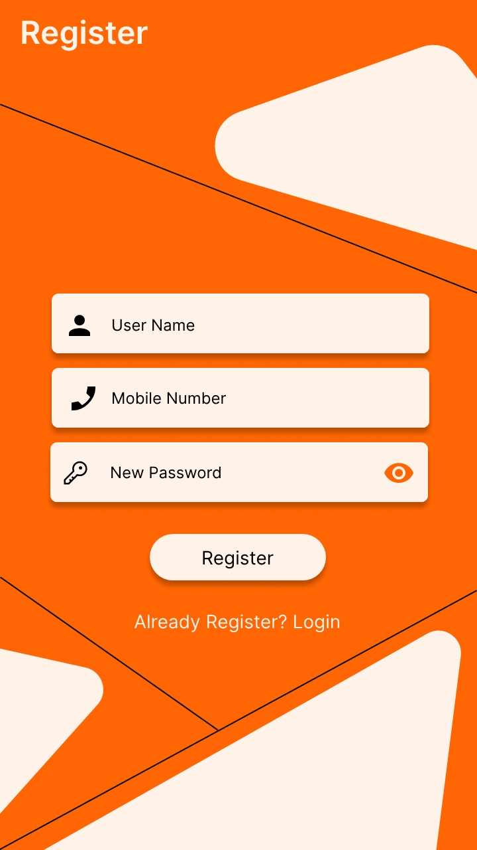

**3.3 Profile:**

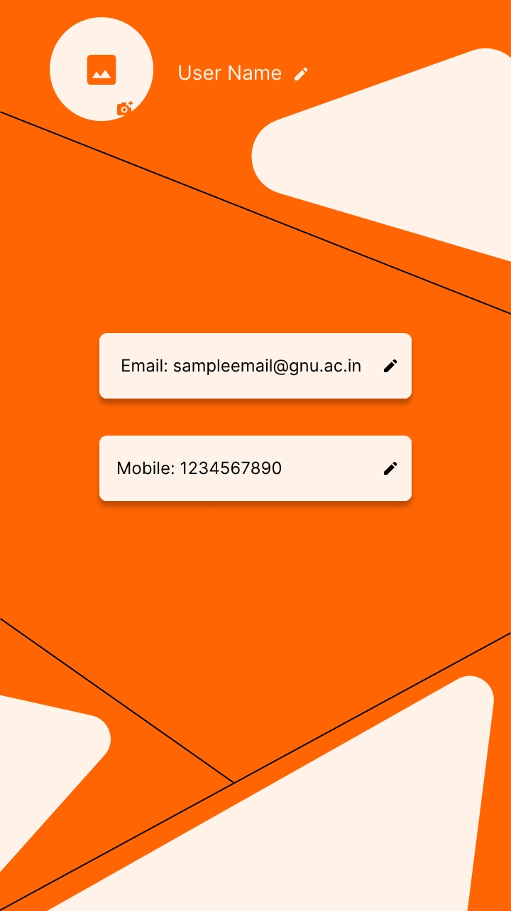

**8.4 ProductList:**

